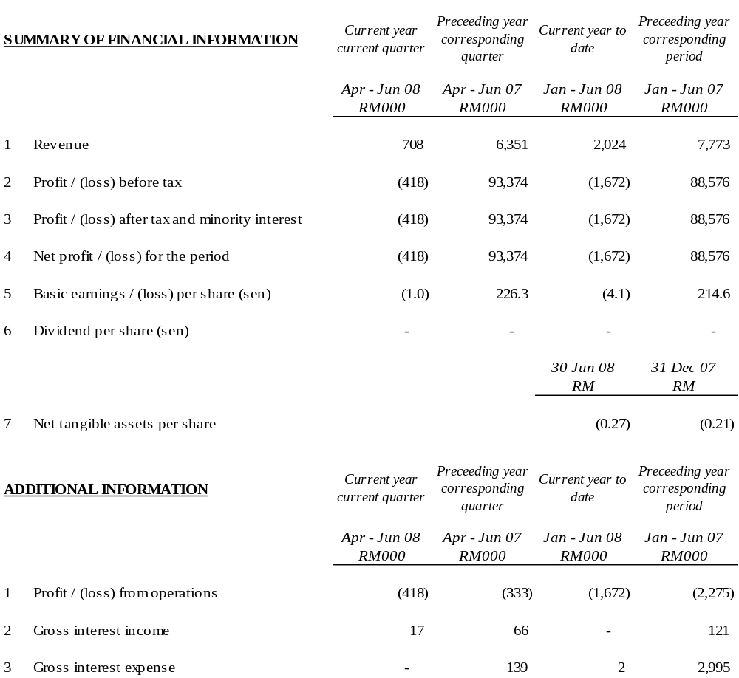

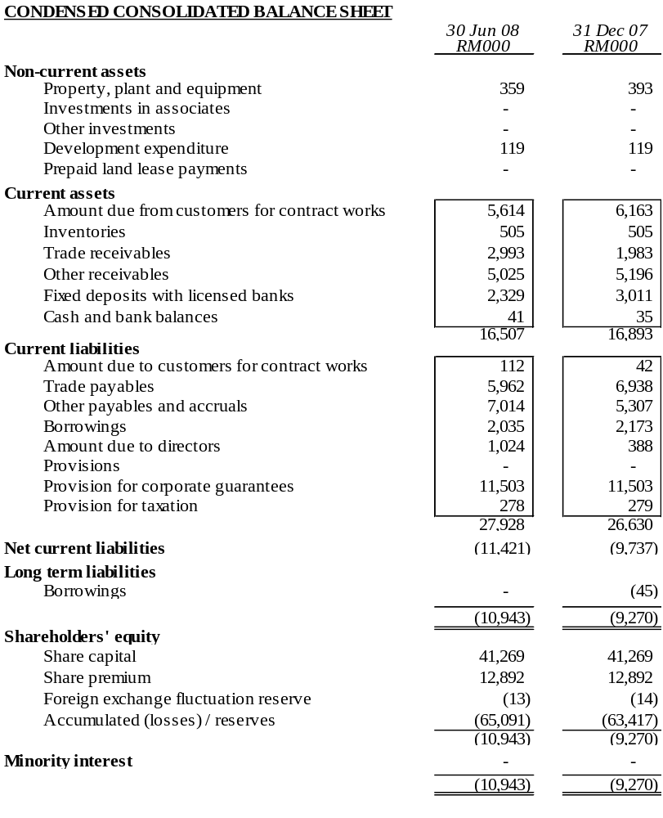

The condensed consolidated balance sheet should be read in conjunction with the Annual Financial Report for the year ended 31 December 2007.

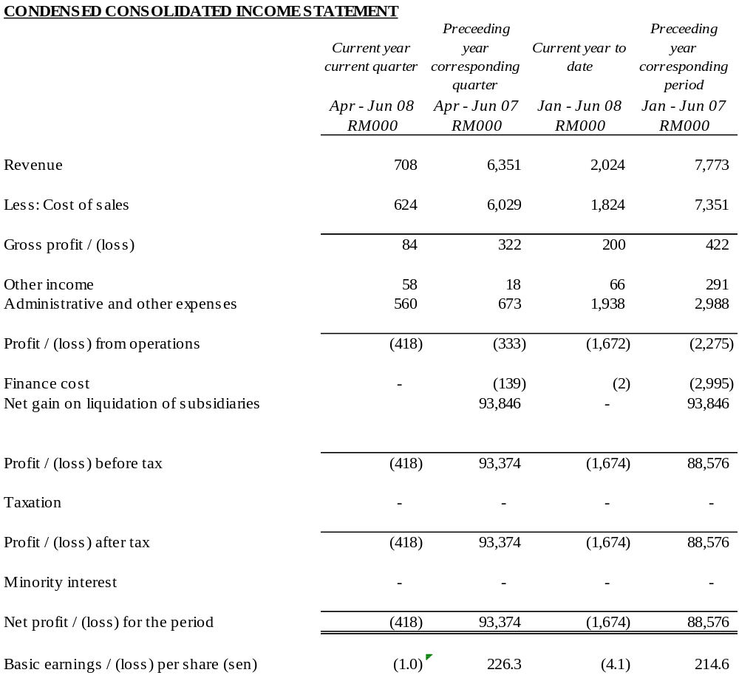

The condensed consolidated income statement should be read in conjunction with the Annual Financial Report for the year ended 31 December 2007.

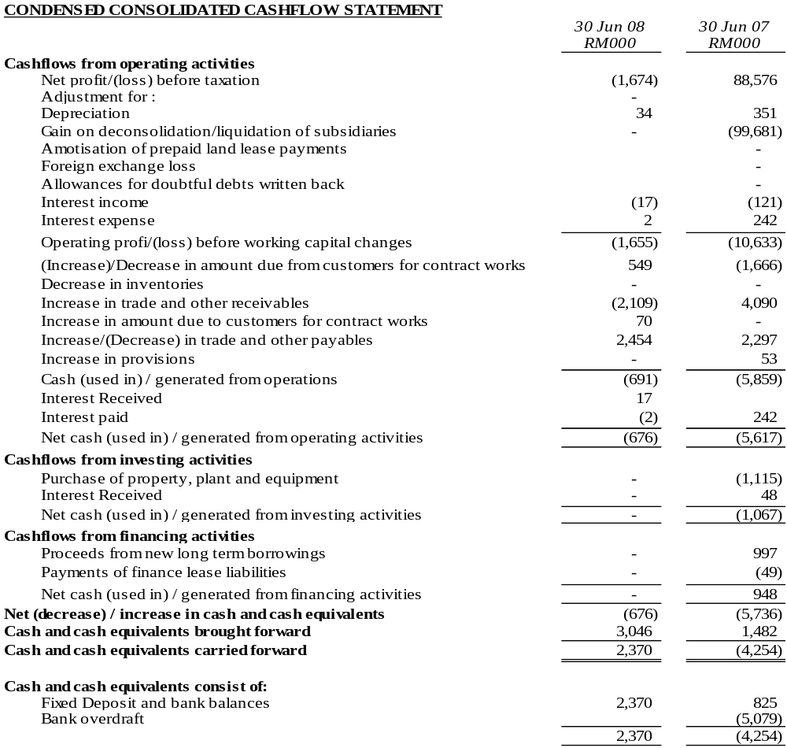

The condensed consolidated cashflow statement should be read in conjunction with the Annual Financial Report for the year ended 31 December 2007.

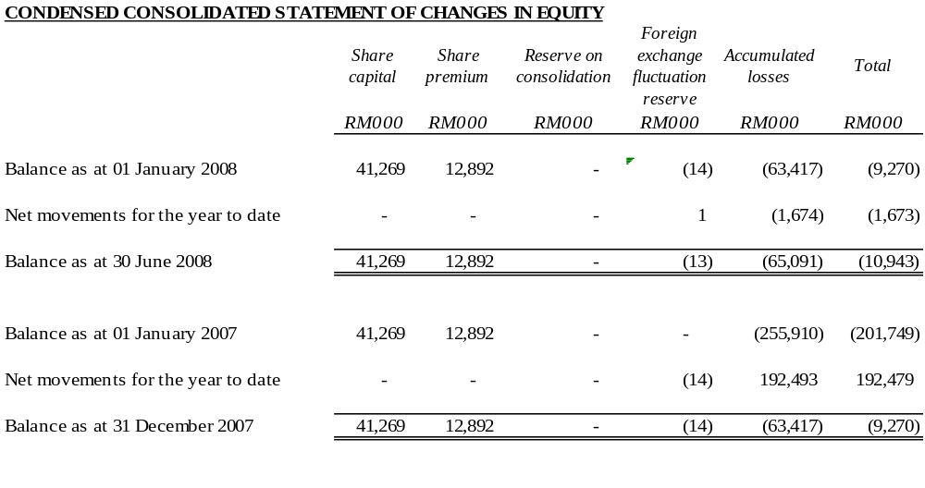

The condensed consolidated statement of changes in equity should be read in conjunction with the Annual Financial Report for the year ended 31 December 2007.

EXPLANATORY NOTES
1. BASIS OF PREPARATION
The interim financial statements are unaudited and have been prepared in accordance with the requirements of Financial Reporting Standard (FRS) 134, Interim Financial Reporting issued by the Malaysian Accounting Standards Board (MASB) and paragraph 9.22 and Appendix 9B of the Listing Requirements of Bursa Malaysia Securities Berhad.
The interim financial statements should be read in conjunction with the audited financial statements of the Group for the year ended 31 December 2007.
2. CHANGE IN ACCOUNTING POLICIES
The accounting policies and methods of computation adopted by the Group in these quarterly financial statements are consistent with those adopted in the most recent annual audited financial statements for the year ended 31 December 2007, except that the Group has adopted the new/revised standards mandatory for annual periods beginning on or after 1 January 2007, as follows:

FRS 117 | Leases
FRS 119₂₀₀₄ (Revised) | Employee Benefits – Actuarial Gains and Losses, Group Plans and Disclosures
FRS 124 | Related Party Disclosures

The adoption of the above FRSs does not have any significant financial impact on the Group.
3. AUDIT REPORT OF PRECEDING FINANCIAL STATEMENT
The annual financial statements of the Group for the year ended 31 December 2007 were reported without qualification.
The Company together with a team of professionals had on 23 January 2007 submitted its Proposed Corporate Restructuring Exercise (“PCRE”) to the Securities Commission (“SC”). The SC had vide their letter dated 30 April 2007 approved the said PCRE (details to which are further explained in Note 10 below).
The Company is presently taking the necessary steps to implement the aforesaid PCRE.
4. EXCEPTIONAL ITEMS

The items affecting assets, liabilities, equity, net income or cashflows that are unusual because of their nature, size or incidence have been included in the interim financial statements. Kindly refer to note 17 for further details.
5. CHANGES IN ESTIMATES
There were no changes in estimates of amounts that give a material effect for the current quarter.
6. TAXATION
Taxation for the current period is as follows:
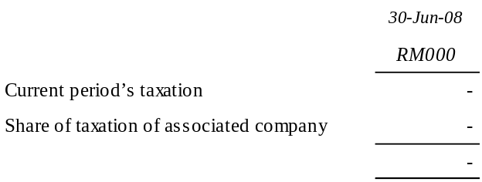
No taxation has been provided in the current year to date.
7. SALE OF UNQUOTED INVESTMENTS / PROPERTIES

There has been no disposal of any unquoted securities or properties during the current quarter.
8. PURCHASE OR DISPOSAL OF QUOTED SECURITIES

There has been no purchase or disposal of any quoted securities during the current quarter.
9. CHANGES IN GROUP COMPOSITION
There has been no change in the Group’s composition during the current quarter.
10. CORPORATE PROPOSALS
The Company had on 23 January 2007 submitted to the Securities Commission (“SC”) its Proposed Corporate Restructuring Exercise (“PCRE”) entailing the following:-

Proposed Capital Reduction;
Proposed Acquisitions;
Proposed Debt Restructuring;
Proposed Liquidation;
Proposed Rights Issue with Warrants; and
Proposed Placement with Warrants
The SC had vide their letter dated 30 April 2007 approved the aforementioned PCRE. In this regard, the Company has commenced the implementation process of the abovementioned PCRE via liquidating its subsidiaries that was not part of the Group moving forward.
In addition, the Company and its affected subsidiaries have also obtained the required majority pursuant to Section 176 of the Companies Act 1965 at their earlier held respective Court Convened Meetings (“CCM”). These CCM were held in line with the Proposed Debt Restructuring Scheme (“PDRS”) which forms part of the said PCRE.
Pursuant to the CCM and Extraordinary General Meeting (“EGM”) of the Company that were held on 28 February 2008, the shareholders of the Company had approved the PDRS and PCRE during the CCM and EGM respectively. The above meetings were conducted in line with the PCRE which was approved by the SC on 30 April 2007.
On 7 April 2008, the Company obtained an order from the High Court of Malaya (“Court Order”) sanctioning the said PCRE pursuant to Section 176 (3) of the Companies Act 1965. In the same Court Order, the High Court of Malaya also confirmed the Proposed Capital Reduction which forms part of the aforementioned PCRE.
Notwithstanding the above, pursuant to Chapter 18 of the SC’s guidelines on Issue/Offer of Securities (being the guidelines under which the PCRE was approved), the PCRE is to be implemented within twelve (12) months from the first approval date of 30 April 2007, i.e. 30 April 2008. In relation thereto, the Company’s adviser, Aseambankers (M) Bhd had vide its letter dated 15 April 2008 sought the SC’s approval for an extension of time of eight (8) months i.e. up to 31 December 2008. Approval from the SC with regard to the above extension was obtained vide its letter dated 27 May 2008.

11. ISSUANCE OF EQUITY SECURITIES AND REPAYMENT OF DEBT SECURITIES, SHARE BUY-BACKS, SHARE CANCELLATIONS, SHARES HELD AS TREASURY SHARES AND RESALE OF TREASURY SHARES
There were no issues of equity securities and repayment of debt securities, share buy-backs, share cancellations, shares held as treasury shares and resale of treasury shares during the current quarter.
- GROUP BORROWINGS
All borrowings by the group and corporate guarantees given by the Company, in respect of credit facilities and certain creditors of Lankhorst Pancabumi Contractors Sdn Bhd (in liquidation) will be addressed by the Company pursuant to the PCRE.
13. OFF-BALANCE SHEET FINANCIAL INSTRUMENTS
There are no off-balance sheet financial instruments in issue.
14. CHANGES IN MATERIAL LITIGATION
There are no other changes in material litigation involving the remaining companies of the Group.
15. SEGMENTAL INFORMATION
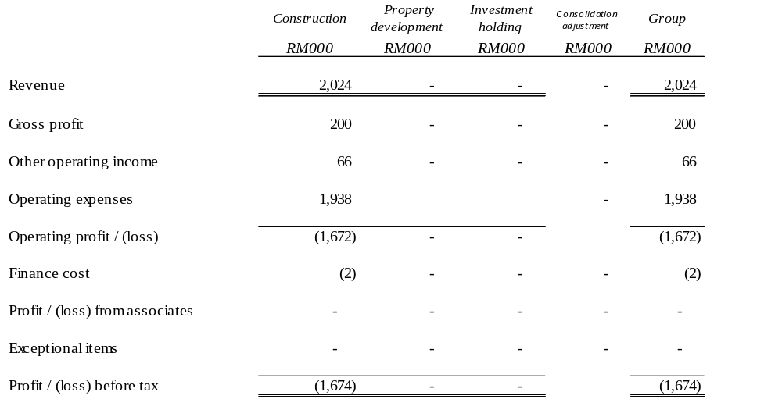
16. REVIEW OF PERFORMANCE

The Group’s revenue reduced by 89% for the second quarter of 2008 as compared to the corresponding quarter in 2007. In addition, the Group recorded a loss before tax of RM0.4 million in the current quarter as compared to a profit before tax of RM93.4 million in the same quarter of the preceding year.
17. EXPLANATORY NOTE ON MATERIAL CHANGE
There has been no material change during the current quarter.
18. MATERIAL EVENTS SUBSEQUENT TO BALANCE SHEET DATE
There have been no material events subsequent to balance sheet date.
19. SEASONAL AND CYCLICA/L FACTORS
There are no significant variations to the level of profit due to seasonal or cyclical effects of operations.
20. EXPLANATORY NOTE ON PROFIT FORECAST/GUARANTEE
No profit forecast / guarantee have been given by the company.
21. PROSPECTS
The Group faces more challenges in an unstable operating environment for 2008. The current international economic and credit upheavals will surely have an impact on business and consumer confidence in addition to the spiraling cost of building materials. During this crucial period, Ark Group will persevere for an improved performance for the balance of the year. The Group will continue with its ongoing efforts to implement the PCRE and improve operational efficiency in order to achieve better results.
22. DIVIDENDS
No interim or final dividend has been declared or recommended.

